Dr. Carita J.B.Gomara  Dr. G. Vinod Chandran  Dr. William T. Leggate  Dr. Samantha J. Bracken |  | All correspondence to:  Purton Surgery  High Street  Purton  Swindon  Wiltshire  SN5 4BD  01793 770207

Dear New Patient

Welcome to Purton Medical Practice

To register as a new patient you need to complete a Registration Form, Ethnic origin form and a New Patient Questionnaire for each patient joining our practice list. We would be grateful if you could complete these forms as fully as possible as it will provide us with the essential information we need for our records.

Please note we are unable to register you with the practice until we have all these completed forms returned to us.

We do not routinely ask you to visit the nurse for a new patient check. Once registered, the Nurse checks the questionnaires and enters the relevant information to your records, if they feel that it may be helpful to meet you to obtain further information and maybe for further routine tests, we will contact you and ask you to make an appointment.

We have a very informative website which you may like to browse: - www.purtonsurgery.co.uk

Could I also take the opportunity to mention that we have an active patient participation group (this is a group made up from our registered patients), the ‘PPG’ help organise health promotions, talks and other events. We are very grateful to anybody who is able to support PPG in any way they can. Please see a message from our PPG chair about further details about the group.

Please contact the Surgery if you have any questions, our receptionists will be happy to help.

Yours sincerely

Mr Kai Howard
Practice Manager

Branch Surgery: Green Gable, 38A High Street, Cricklade, Swindon, Wilts. SN6 6AY (01793 752633)

Dear new patient,

On behalf of the Patient Participation Group, hello & welcome to our surgery.
We are a small committee of patients with others working alongside when extra help is needed.

We meet at the surgery on the first Thursday of each month.

Please find below some of the activities in which we engage:

- Educational evenings when we invite medical professionals to speak on a variety of issues.
- Helping at flu clinics
- Fundraising for medical items for the patients that the NHS no longer provide.
- Affiliated to NAPP National Association of Patient Participation which has an annual conference
- Attending meetings of the Wiltshire Clinical commissioning Group

If you would like to become involved in any way we would love to hear from you.
Please contact groupforpatients@gmail.com

PLEASE REST ASSURED THAT AT NO TIME ARE YOUR PERSONAL AND MEDICAL RECORDS ACCESSIBLE BY ANY MEMBER OF THIS COMMITTEE.

Warm wishes,

Marietta Crockford
PPG Chair

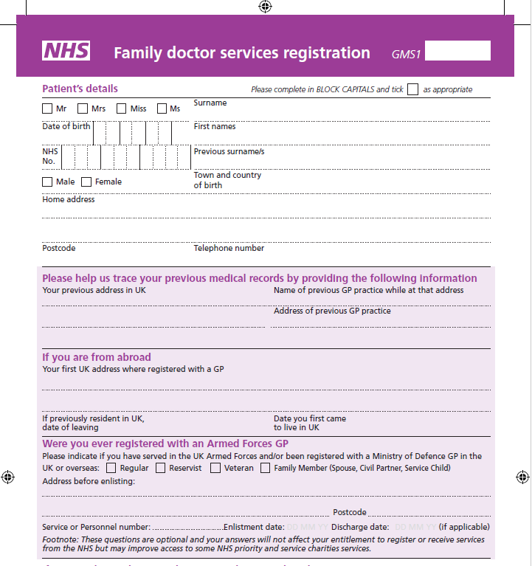
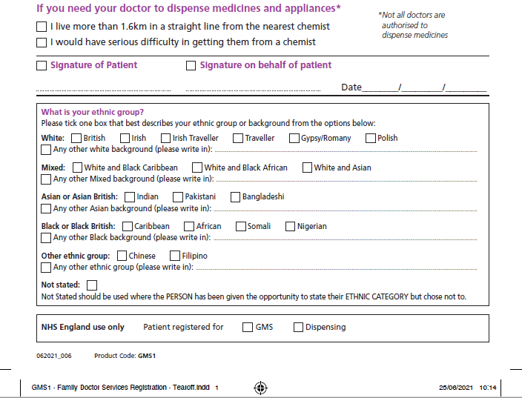

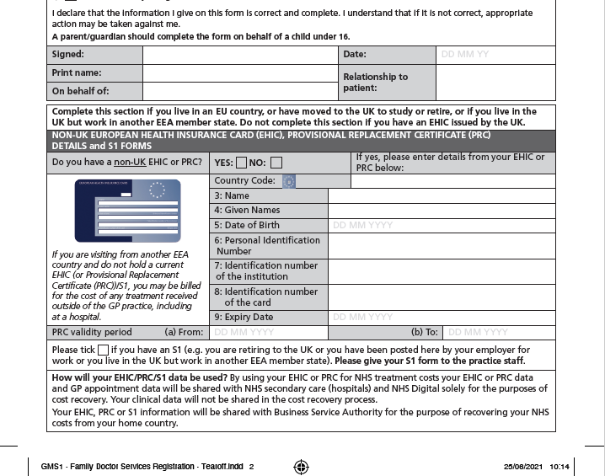
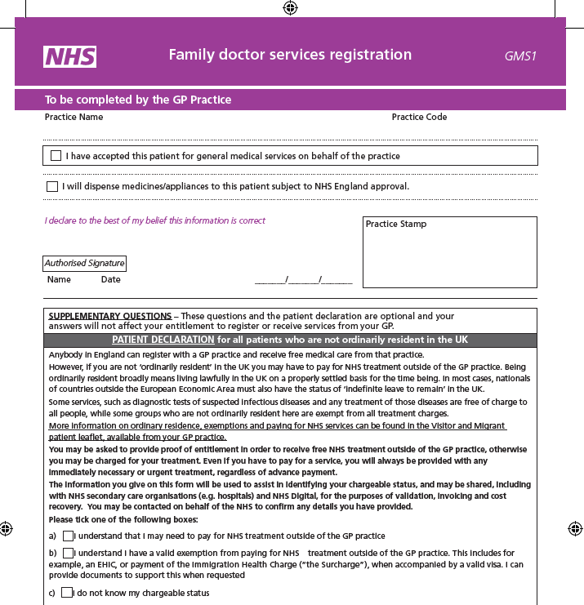

PUrton Surgery New Patient Questionnaire
Please complete as much of the questionnaire as possible & return it with your Registration Forms to Purton Surgery.

Title: ……………………………………………….…

Surname: ………………………………………………………………………………......................

Forenames: ……………………………………………………DOB:………………………………….…......................

Address:……………………………………………………………………………………………………………………..

……………………………..………………………………………………Postcode: …………………………………….

Home Tel No: …………………….………… Mobile Tel No: ………………………………………...…………………
Would you like to receive text message reminders from the surgery (appointments/health campaigns etc.)?
YES / NO

Occupation / School: ………………………………………………………………………………………...………………………….

Next of Kin: ………………………………… Next of Kin contact no: …………………………………………………..

Relationship of Next of Kin: …………………………………………………………………………………………….…….............

MEDICAL HISTORY. Please list below any major illnesses/operations (in date order if possible). Please continue on a separate sheet if necessary.
Date | Illness / Operation

Do you have any drug allergies? (if yes, please specify)

Please list below all medication currently on your repeat prescription. Please use a separate sheet if needed.
Name of Medication | Medication Strength | Daily dose

Family History. Please list below any major illnesses suffered by any close family members (e.g. diabetes, asthma high blood pressure, heart disease etc.)
Family Member | Illness

LIFESTYLE
Do you smoke? If yes, how many per day?
Cigarettes  Roll your own | Cigars  Pipe | Other  No

Do you drink alcohol? (if yes, how many units per week?)
1 unit = 1 small glass of wine
1 measure of spirits or ½ pint beer

HEIGHT | WEIGHT

Do you exercise?
Type of exercise and how often? (i.e. once a week or more?)

IMMUNISATIONS
Have you ever had a course of Tetanus & Polio Vaccine: YES / NO DATE: ..................................................................
If you are aged between 18 and 24 have you had a Men C Vaccination YES / NO DATE: …………………………..……

(If the answer is no to either of the above questions please make an appointment with one of our Practice Nurses to update your immunisation cover)

FEMALE PATIENTS (if you have a coil fitted please answer the following questions)
What type? (e.g. Mirena) | When was it inserted? | Where was it inserted e.g. Hospital or GP | When was it last checked?
Do you use another form of contraception? If so, please state

- How often do you have a drink containing alcohol?
Never  2 – 3 times a week | 4 or more times a week  2 – 4 times month | Monthly or less
- How many standard drinks containing alcohol do you have on a typical day?
1 or 2  3 or 4 | 5 or 6  7 or 9 | 10 or more
- How often do you have six or more drinks on one occasion?
Weekly  Daily or almost daily | Never  Less than monthly | Monthly
All information given is correct at today’s date

Signed ………………………………………………………………………Today’s Date………………………..
NHS Summary Care Record with additional
information

If you are registered with a GP practice in England you will have a Summary Care Record (SCR), unless you have previously chosen not to have one. It includes important information about your health:
- Medicines you are taking
- Allergies you suffer from
- Any bad reactions to medicines

You may need to be treated by health and care professionals that do not know your medical history. Essential details about your healthcare can be difficult to remember, particularly when you are unwell or have complex care needs. Having an SCR means that when you need healthcare you can be helped to recall vital information.
SCRs can help the staff involved in your care make better and safer decisions about how best to treat you.
You can choose to have additional information included in your SCR, which can enhance the care you receive. This information includes:
- Your illnesses and health problems
- Operations and vaccinations you have had in the past
- How you would like to be treated - such as where you would prefer to receive care
- What support you might need
- Who should be contacted for more information about you

What to do next
If you would like this information adding to your SCR (or the SCR of someone you are a carer for), then please complete this form, for return to the relevant GP surgery.
Name of Patient: ………………………………………………..….....................................

Date of Birth: ……………………………. Patient’s Postcode: ………………………….

Surgery Name: ………………………….. Surgery Location (Town): ……….................

NHS Number (if known): …………………………..………………....................................

If you are filling out this form on behalf of another person, please ensure that you fill out their details above; you sign the form above and provide your details below:
Name: ………………………………………………………………………………………….

Parent | Legal Guardian | Lasting power of attorney for  health and welfare
Capacity:
Please circle one
If you require any more information, please visit www.hscic.gov.uk/scr/patient phone HSCIC on 0300 303 5678 or speak to your GP Practice
For practice use: To update the patient’s consent status to ‘Express consent for medication, allergies, adverse reactions and Additional Information’ use the SCR consent preference dialogue box or add Read code 9Ndn (or CTV3 code XaXbZ for SystmOne practices).

